COMP.2030 Lab 12/3-4/19

NAME: Ryan Balachandran

 | rrmov rA, rB
Fetch | iCode:iFun <- M₁[PC]  rA:rB <- M₁[PC+1]  valP <- PC+2
Decode | valA <- R[rA]  valB <- 0
Execute | ValE <- ValA + ValB
Memory

Write Back | R[r] <- ValE
PC Update | PC <- ValP
- For the following three Y86 instructions, write operation and data transfers in each stage of its execution referring to the diagram on the right. ‘rrmov’ instruction is an unconditional move from rA register to rB.

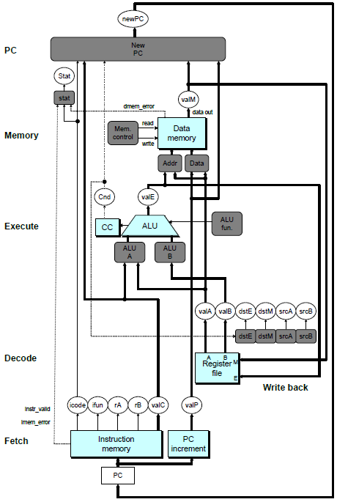
 | mrmovq D(rB), rA | callq Dest
Fetch | iCode:iFun <- M₁[PC]  rA:rB <- M₁[PC+1]  valC <- M₈[PC+2]  valP <- PC+10 | iCode:iFun <- M₁[PC]  valC <- M₈[PC+1]  valP <- PC+9
Decode | ValB <- R[rB] | ValB <- R[%rsp]
Execute | valE <- valB + valC | valE <- valB + -8
Memory | valM <- M8[valE] | M8[valE] <- valP
Write Back | R[rA] <- valM | R[%rsp] <- valE
PC Update | PC <- valP | PC <- valC

- Shown on the right is the implementation of Y86 Sequential control. Specify in terms of SEQ control resources the operations that are performed in Execute and Memory phases of instruction execution cycle of push instruction.

stage | pushq rA
Decode | valA <- R[%esp]  valB <- R[%esp]
Execute | valE <- valB + -8
Memory | M4[valE] <- valA

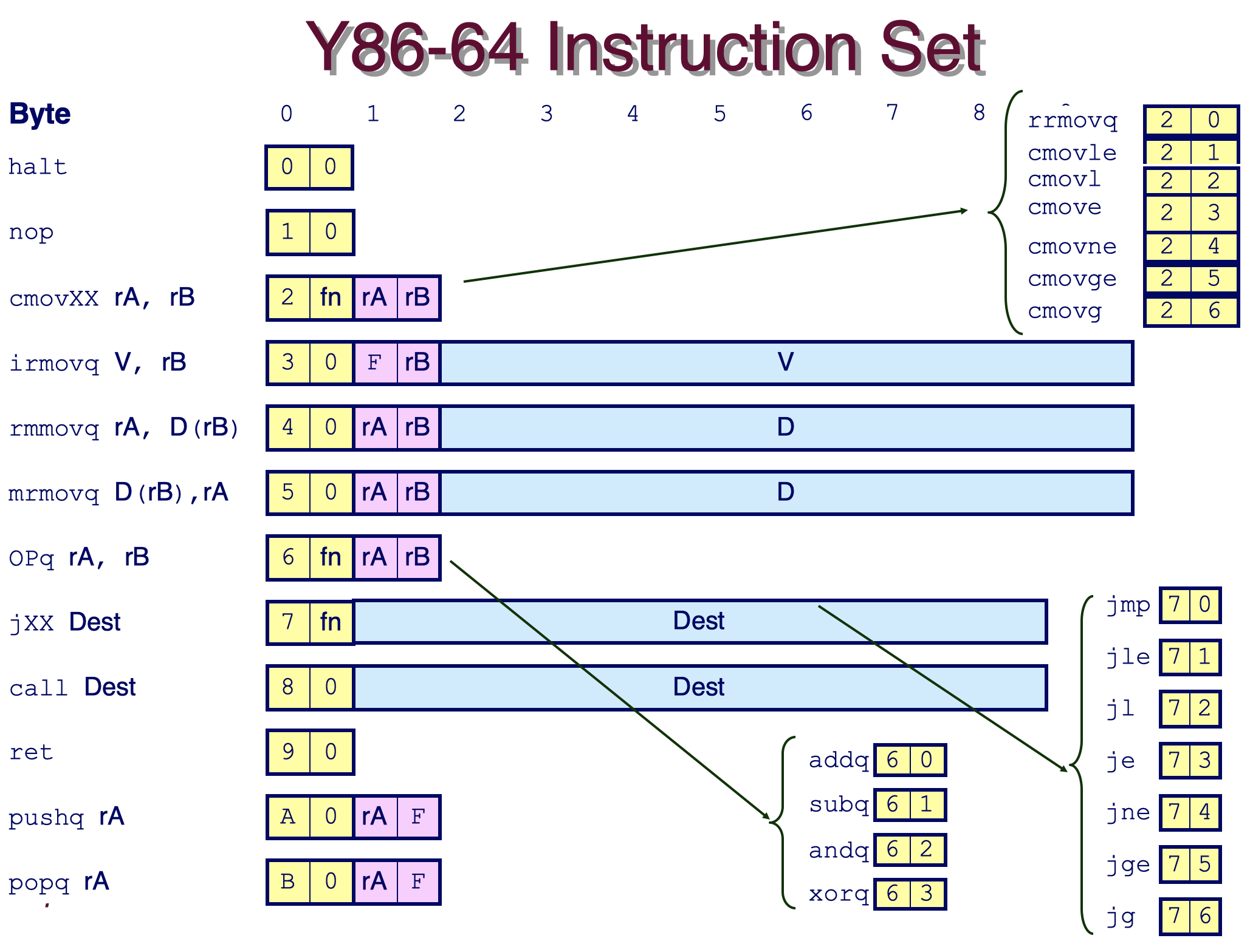
- In the SEQ control, the input port A of the ALU selects between valC and valA in the SEQ control structure (gray box labeled ALU A in the diagram above).

Which instructions from the Y86 instructions on the right need valC selected by the ALU A ? List their iCode values.

3, 4, 5

Which instructions from the Y86 instructions on the right need valA selected by the ALU A ? List their iCode values.

2, 6, A

